STRETCHING AND ICING

THE INSTITUTE FOR ANKLE AND PODIATRIC MEDICINE AND SURGERY
PLANTAR FASCIITIS REHAB

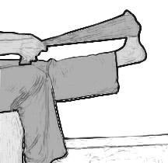
WHILE STILL IN THE BED
Stretch your toes and ankles back
toward your face until you feel a
mild stretch; hold for 5-10 seconds.
Curl your toes down and arch your
foot until you feel a stretch; hold
5-10 seconds.
Alternate above exercises for 10 reps.

Assisted Calf Stretch
Sitting with feet in front and knees extended,
place a towel or a belt under your
forefoot and stretch your toes toward
you; hold 10 seconds. Repeat 15 times.

Towel Exercises
Sit with the towel on the floor in front of you on a slick surface. First draw the towel in toward you by pulling with your toes. Keep heel touching the floor. Second, push the towel toward the outside. Keep the towel touching the floor. Third, pull the towel in toward the middle. Keep heel flat. Repeat 15 times each way.
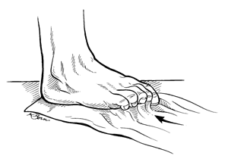
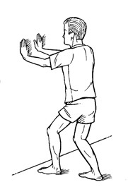

STAND AND DO THE FOLLOWING

Stand and face the wall with your arms
out stretched to support you. Place
your opposite foot forward and your hurt
foot behind. Lean toward the wall keeping
your back heel on the floor and stretch. Hold 10
seconds. Repeat with back knee slightly bent.
Do 15 to 20 reps of each.

Standing with the ball of your foot on stair,
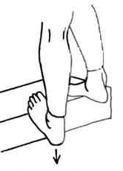
reach for the bottom step with your heel
until a stretch is felt through the arch of the
foot. Hold 10 seconds. Relax. Repeat 15 time.
Do 3 sessions per day.

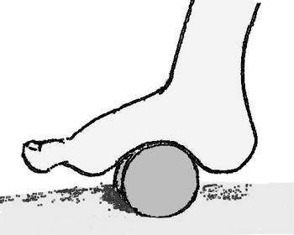
To Ice/Stretch
Use a frozen can of orange juice,
a frozen bottle of water, or a can of soup to roll
your arch on and stretch your foot.

ABC’s
When sitting down watching TV or sitting at a desk, extend your leg out and write the ABC’s with your foot. (Pretending your big toe is a pencil, moving at the ankle not the hip)

Additional Exercises
Marble pick-up using your toes 15-20 minutes.
Golf ball/ tennis ball stretch 5-10 minutes. Roll foot forward, backward, circular, side-to-side, alternating each direction every 1-2 minutes.
Extend big toe until a mild stretch is felt. Hold 10 seconds. Relax and repeat 3 times.

ALWAYS REMEMBER (RICE)
R-REST -STAY OFF OF YOUR FEET AS MUCH AS POSSIBLE
I -ICE –ICE DAILY
C-COMPRESSION –USE AN ACE BANDAGE FOR SUPPORT
E-ELEVATION –PROP YOUR FEET UP AS MUCH AS POSSIBLE

PLANTAR FASCIITIS
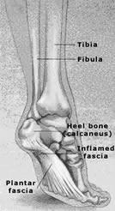
Your doctor has diagnosed your condition to
be plantar fasciitis. Plantar fasciitis is a
common problem among people who
are active in sports or whose occupation
requires them to be on their feet a
significant amount of time. Your symptoms
may have been dull intermittent pain in the
heel that progressed to a sharp persistent pain.
Often it is worse in the morning with the
first few steps, after sitting, after standing or walking,
and at the beginning of sport activities.

The plantar fascia is a thick fibrous material on the bottom of the foot. It runs from the toes to the heel. Problems can occur when you have weak foot muscles, tight foot muscles, or low arches. All of these can cause stress to the plantar fascia thus causing irritation.
There are a number of things you can do to treat plantar fasciitis:

- You have been given exercises to strengthen and stretch your foot and ankle. Compliance to these exercises will help you recover more quickly.
- The shoes you wear will affect your recovery. Shoes that provide a good supportive fit through the arch and a good snug heel counter should be worn. It is best to avoid barefoot walking and shoes that maximize heel contact pressures such as no heel, flip flops, or “Earth” style shoes.
- Small plastic heel cup inserts may help relieve heel pain. Your physician may also suggest an orthotic device or arch taping to reestablish the arched shape of the foot.
- Gentle massage of the muscles across the arch and the heel using an over the counter muscle rub may help (i.e.: Bio freeze, Icy Hot, etc.). The ice massage following exercise and activity will also be a benefit.

The goal is to decrease the discomfort and improve the flexibility and strength of your foot. This must be done with the realization that it may take a long time in getting well with patience and persistence as your guide.

